**Assignment 9**

Create an image of the instance that you want to migrate

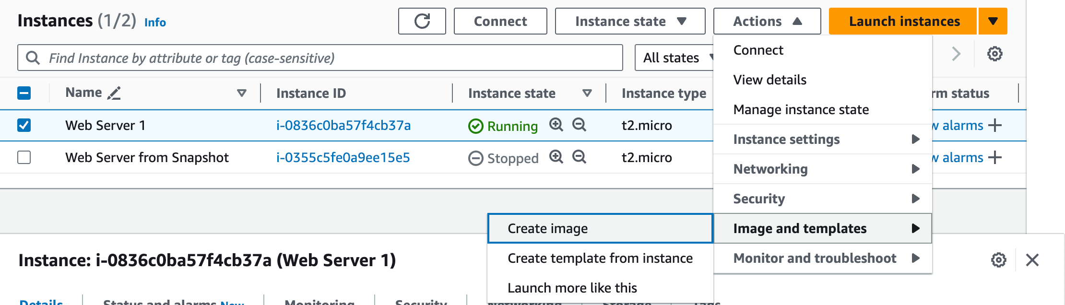

Give name and description and click on create image

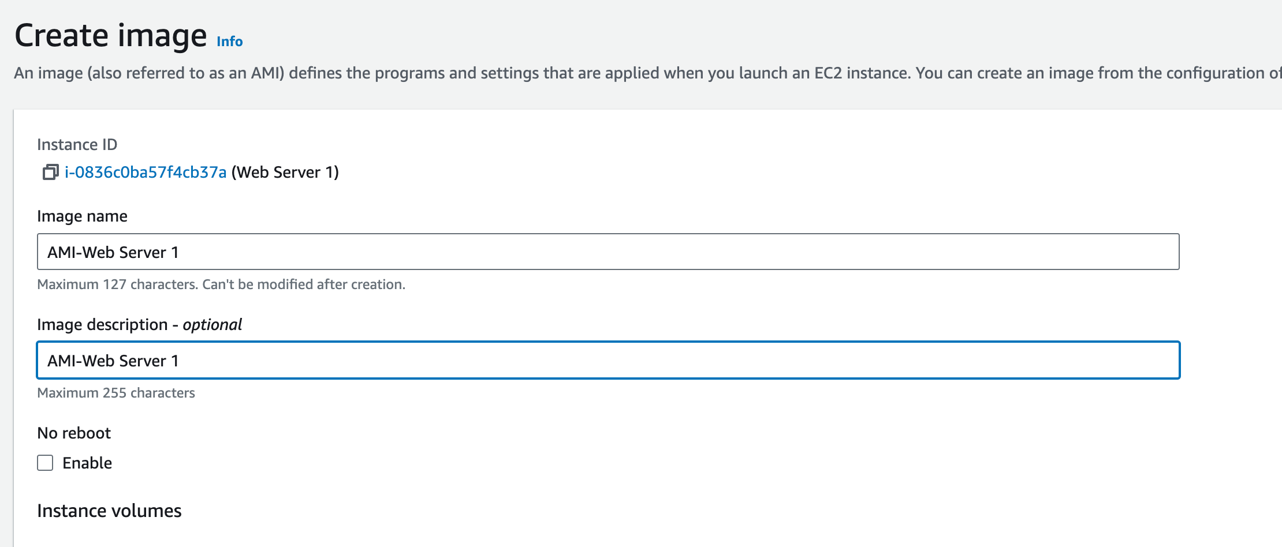

Go to AMIs to see the image that is just created

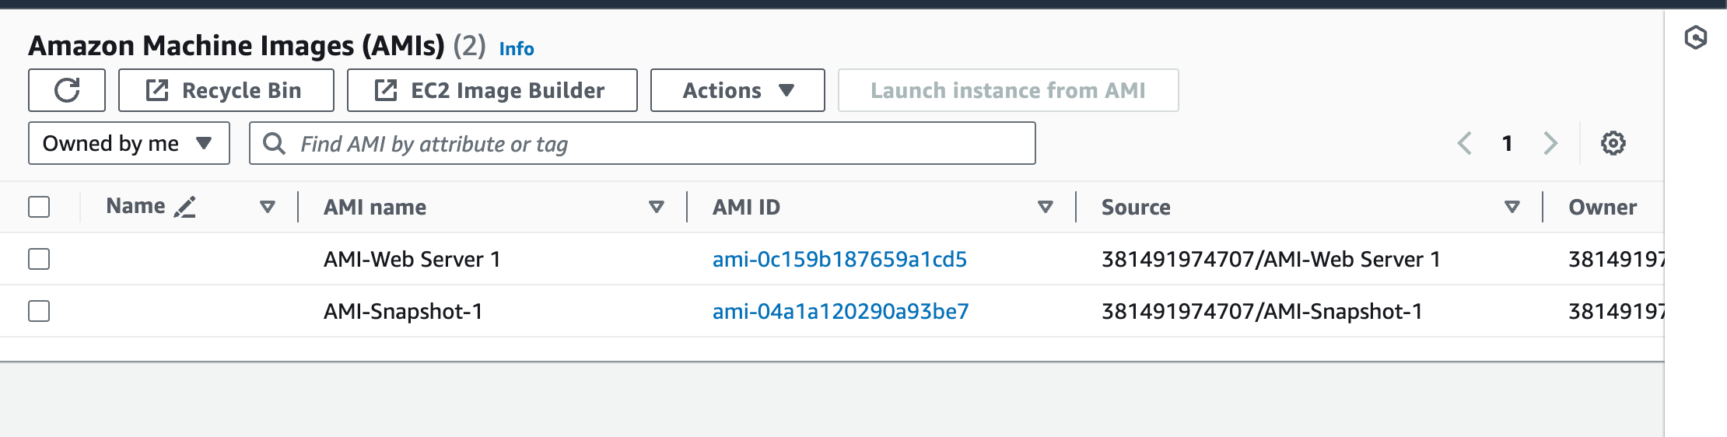

Now create a new AWS account

Now copy the account ID of the new account

and give the access of the image to the newly created

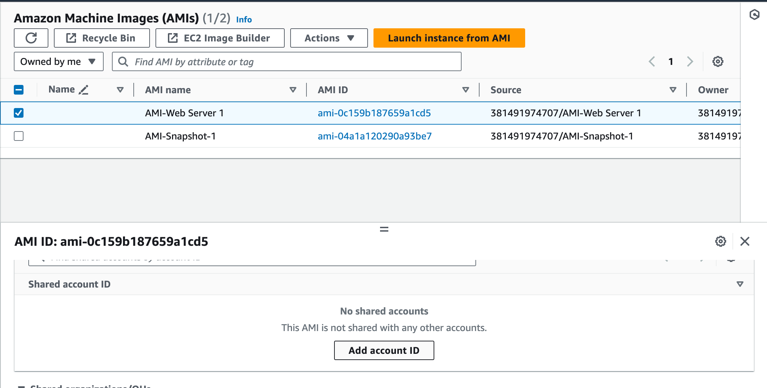

The shared image can be seen in the new account

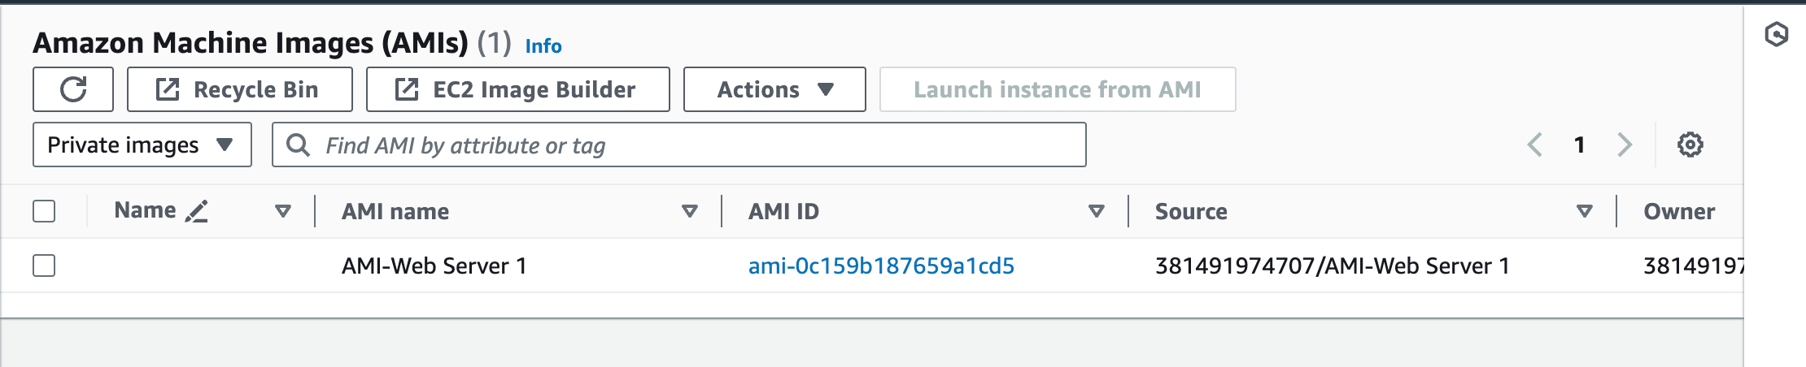

Now click on that instance and launch an instance on the new account like we did before

After creating an instance we have successfully migrated a live VM to a different account

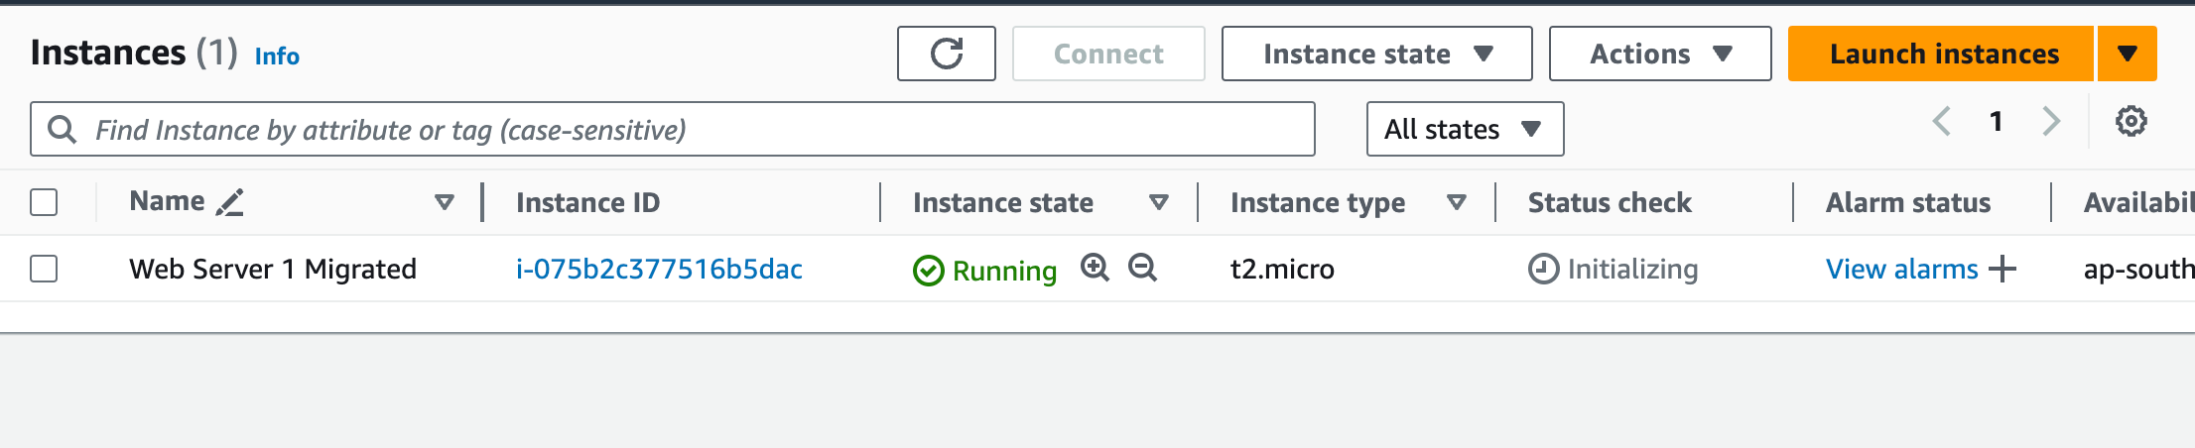

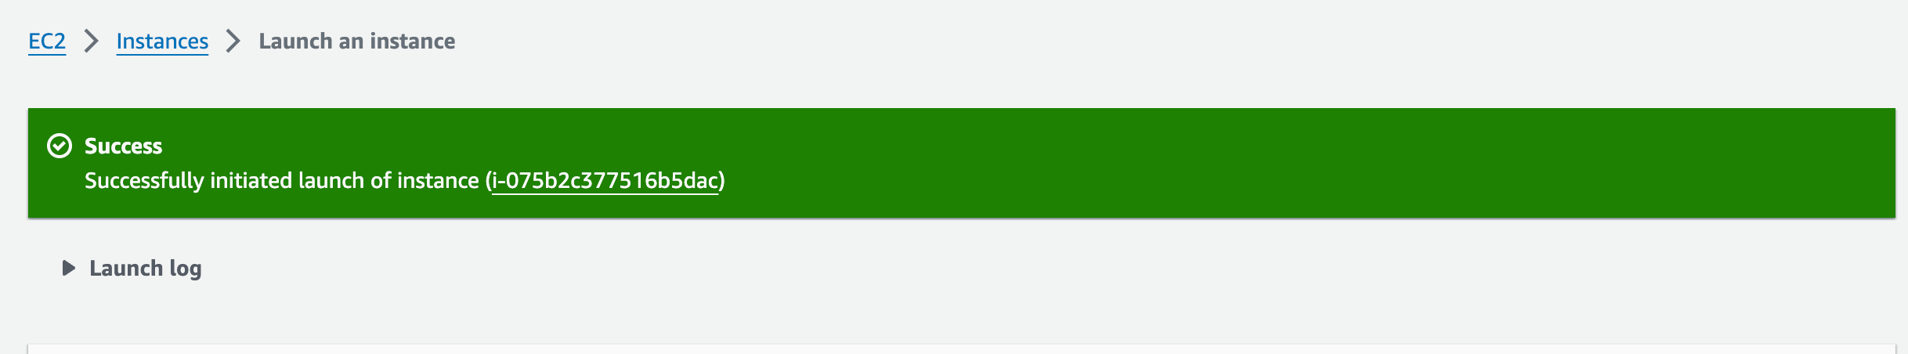

Now we can see our existing web page in our migrated server

